CUSTOMER SEGMENTATION USING MACHINE LEARNING IN R
An Industry Oriented Mini Project report submitted in partial fulfillment of requirements for the award of the degree of

Bachelor of Technology in Computer Science Engineering

Submitted by
Name: N.Srikar Roll. No: 19131A05G1
Name: P.Divyagandh Roll. No: 19131A05H7
Name: P.Hema Harsha Vardhan Roll.No: 19131A05H4
Name: A.Nithin Roll.No: 19131A05G0
GAYATRI VIDYA PARISHAD COLLEGE OF ENGINEERING(A)
MADHURAWADA, VISAKHAPATNAM-530048
(2019-23 Batch)
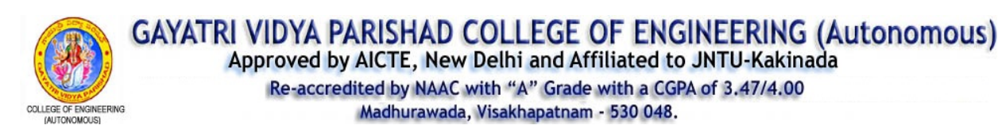

CERTIFICATE
This is to certify that the Mini project work titled is Customer Segmentation Using Machine Learning In R a bonafide record of the work done by N.Srikar(19131A05G1), P.Divyagandh(19131A05H7), P.Hema Harsha Vardhan (19131A05H4), N.Nithin(19131A05G0) to the Department of Computer Science and Engineering, Gayatri Vidya Parishad College of Engineering (Autonomous), Visakhapatnam, affiliated to Jawaharlal Nehru Technological University, Kakinada in partial fulfillment of the requirements for the award of the degree of Bachelor of Technology in Computer Science and Engineering during the academic year 2022-2023

Under the guidance of : Head of the Department:
Dr. H Parthsarathi Patra Dr.D.N.D.Harini
Associate Professor Associate Professor and
Dept. of CSE, Head of the Department
GVPCOE(A) Dept. of CSE,
GVPCOE(A)

ACKNOWLEDGEMENTS

We express our deep sense of gratitude to our esteemed institute “Gayatri Vidya Parishad College of Engineering (Autonomous)” which has provided us an opportunity to fulfill the most cherished desire to reach our goal.
We express our deep sense of Gratitude to Dr. D.N.D. HARINI, Associate Professor and Head of the Department of Computer science and Engineering, Gayatri Vidya Parishad College of Engineering (Autonomous) for giving us an opportunity to do the project in college.
We express our profound gratitude and our deep indebtedness to our guide Dr. H Parthsarathi Patra, Associate Professor, Department of Computer Science and Engineering, whose valuable suggestions, guidance, and comprehensive assistance helped us a lot.
With a great sense of pleasure and privilege, I extend my gratitude and sincere thanks to, DR. A. BALA KOTESWARA RAO, Principal, Gayatri Vidya Parishad College of Engineering (Autonomous) for his continuous encouragement during the study.
We also thank our coordinator, Dr. CH. SITA KUMARI, Sr.Assitant Professor, Department of Computer Science and Engineering, for the kind suggestions and guidance for the successful completion of our project work
Our deep hearted thanks to the faculty members of our department for their value-based imparting of theory and practical subjects, which we have to put into use in our project.
We are indebted to the non-teaching staff for their cooperation. We would like to thank our parents and friends for all their help and support in making our project a success.
Declaration of the student
We, the undersigned solemnly declare that this report is based on the Mini Project carried out by Us during the study (2021-22) for the partial fulfillment for the award of degree Bachelor of Technology in Engineering.
I further declare that the proofs submitted are genuine to the best of my Knowledge
Signatures of the Students:
Name of the Student | Signature
N. Srikar
P. Divyagandh
P. Hema Harsha Vardhan
A.Nithin

- INTRODUCTION
  - OBJECTIVE
  - ABOUT THE APPLICATION
Different stages of the application
a)Authentication
b)Backend Server
c)Frontend Server

a)Authentication:
b)Backend Server:
c)Frontend Server:
1.3 PURPOSE
1.4 SCOPE

- SRS DOCUMENT

A software requirements specification (SRS) is a document that describes what the software will do and how it will be expected to perform

2.1 FUNCTIONAL REQUIREMENTS
A Functional Requirement (FR) is a description of the service that the software must offer. It describes a software system or its component. A function is nothing but inputs to the software system, its behavior, and outputs. It can be a calculation, data manipulation, business process, user interaction, or any other specific functionality which defines what function a system is likely to perform. Functional Requirements are also called Functional Specification
      - Analyse the Result Data as per the Application
      - Display all the Classified Data on the Web Application
2.2 NON-FUNCTIONAL REQUIREMENTS

NON-FUNCTIONAL REQUIREMENT (NFR) specifies the quality attribute of a software system. They judge the software system based on Responsiveness, Usability, Security, Portability. Non-functional requirements are called qualities of a system, there are as follows:
      - Performance: The Average Response time of the system is less
      - Reliability: The System is highly Reliable
      - Operability: The interface of the system will be consistent
      - Efficiency: Once the user has learned about the system through his interaction, he can perform the task easily
      - Understandability: Because of user-friendly interfaces, it is more understandable to the users
2.3 MINIMUM HARDWARE REQUIREMENTS
      - Processor: Intel Core i5
      - Hard Disk: 1 TB
      - RAM: 8 GB

2.4 MINIMUM SOFTWARE REQUIREMENTS
For this application, a combination of different software’s are used
      - XAMMP Server
- Apache
- My SQL
      - Python
      - DJANGO 3.0
      - REACT JS

3. ANALYSIS
3.1 EXISTING SYSTEMS
The Present system of result analysis takes a lot of time and manpower for the detailed analysis of the Result. As it is performed the Human there will be a chance of error and also a lot of time-consuming processes and takes a lot of effort from the user
DRAWBACKS OF EXISTING ALGORITHMS
- Inaccessibility:
Administering paper-based evaluations in class may exclude certain students from participating. Students who are absent from class, or who have impairments, may not be able to access or complete the evaluation. The inability to accommodate all students in the process can lead to incomplete, skewed feedback with a very narrow viewpoint.
- Lower quality data:
Many factors can affect the quality of data retrieved through in-class paper evaluations. Students may feel that their responses are not anonymous and worry that instructors can trace the feedback to them. They may feel their anonymity is compromised due to their writing or by the comments they divulge. This causes students to be less open and honest on their assessments. Other issues such as peer pressure and in-class evaluation time limits can also negatively affect the quality of the data collected.
- Limited flexibility:
Using traditional paper-based assessments often does not allow for the customization of questions. The questions used may be standard, the university set queries without instructors being able to add tailored course-specific questions. Using a paper-based process also doesn’t afford much flexibility in terms of the reports that can be generated for instructors and faculty. Standard reports are often used without the ability to present results differently, whether showing results over time or across multiple courses.
- Lengthy process:
The process of administering paper-based assessments is a lengthy one. It can take several months to complete the cycle from administering the forms to collecting and analyzing the results, to sharing reports and acting on the feedback obtained. As instructors do not receive results quickly, valuable time is lost in responding to student concerns and implementing possible course changes.
- High cost:
A major disadvantage of using paper assessments is the high cost associated with the process. The number of personnel involved as well as the printing, distributing, scanning, rekeying, filing, and archiving is very costly. When institutions move to an online system these significant costs can often be reduced by at least 50 percent.
- Non-eco-friendly:
A lot of paper is needlessly wasted in the traditional evaluation process. Wasting such a valuable environmental resource often goes against the institution’s ‘green’ initiatives and university-wide goals.
3.2 PROPOSED MODEL
As we are making the complete process automated the chances of errors and the lengthy process will be minimized so that the long process of manual analysis will be reduced
ADVANTAGES OF PROPOSED MODEL
- Accessibility:
Administering paper-based evaluations in class may exclude certain students from participating. Students who are absent from class, or who have impairments, can be able to access or complete the evaluation. The ability to accommodate all students in the process can lead to completing, the analysis
- High-quality data:
As the data is more secured and stored with some high-quality measurements the students can trust the Institution In such a way that the data can be more anonymous and be safe
- Flexibility:
As the data in this proposed model is completely flexible than that of the Paper-based data which cannot be flexible the data can be changed as per the Institution requirements
- Cost Efficient:
All the costs which will be spent in the traditional process can be saved and the cost can be saved more efficiently
- Eco-friendly:
A lot of paper is needlessly wasted in the traditional evaluation process. All the paper and natural resources can be saved
3.3 FEASIBILITY STUDY
A feasibility study is an analysis that takes all a project's relevant factors into account including economic, technical, legal, and scheduling considerations to ascertain the likelihood of completing the project successfully. A feasibility study is essential to evaluate any proposed project is feasible or not. A feasibility study is simply an assessment of the practicality of a proposed plan or project.
The main objectives of feasibility are mentioned below:

To determine if the product is technically and financially feasible to develop is the main aim of the feasibility study activity. A feasibility study should provide management with enough information to decide:
- Whether the project can be done
- To determine how successful your proposed action will be
- Whether the final product will benefit its intended users.
- To describe the nature and complexity of the project
- What are the alternatives among which a solution will be chosen (During subsequent phases)
- To analyze if the software meets organizational requirements
There are various types of feasibility that can be determined. They are:
- Operational - Define the urgency of the problem and the acceptability of any solution, including people-oriented and social issues: internal issues, such as manpower problems, labor objections, manager resistance, organizational conflicts, and policies; also, external issues, including social acceptability, legal aspects, and government regulations
- Technical: Is the feasibility within the limits of current technology? Does the technology exist at all? Is it available within a given resource?
- Economic - Is the project possible, given resource constraints? Are the benefits that will accrue from the new system worth the costs? What are the savings that will result from the system, including tangible and intangible ones? What are the development and operational costs?
- Schedule - Constraints on the project schedule and whether they could be reasonably met
3.3.1 Economic Feasibility:
The economic analysis could also be referred to as cost/benefit analysis. It is the most frequently used method for evaluating the effectiveness of a new system. In economic analysis, the procedure is to determine the benefits and savings that are expected from a candidate system and compare them with costs. Economic feasibility study related to price, and all kinds of expenditure related to the scheme before the project starts. This study also improves project reliability. It is also helpful for the decision-makers to decide whether the planned scheme is processed later or now, depending on the organization's financial condition. This evaluation process also studies the price benefits of the proposed scheme. Economic Feasibility also performs the following tasks:
- Cost of packaged software/ software development
- Cost of doing full system study
- Is the system cost Effective?

3.3.2 Technical Feasibility:
A large part of determining resources has to do with assessing technical feasibility. It considers the technical requirements of the proposed project. The technical requirements are then compared to the technical capability of the organization. The systems project is considered technically feasible if the internal technical capability is sufficient to support the project requirements. The analyst must find out whether current technical resources can be where the expertise of system analysts is beneficial, since using their own experience and their contact with vendors they will be able to answer the question of technical feasibility. Technical Feasibility also performs the following tasks.
- Is the technology available within the given resource constraints?
- Is the Technology can handle the solution
- Determines whether the relevant technology is stable and established
3.3.3 Operational Feasibility:
Operational feasibility is a measure of how well a proposed system solves the problems and takes advantage of the opportunities identified during scope definition and how it satisfies the requirements identified in the requirements analysis phase of system development. The operational feasibility refers to the availability of the operational resources needed to extend research results beyond on which they were developed and for which all the operational requirements are minimal and easily accommodated. In addition, the operational feasibility would include any rational compromises farmers make in adjusting the technology to the limited operational resources available to them. The operational Feasibility also perform tasks like
- Does the current mode of operation provide adequate response time?
- Does the current operation make maximum use of resources
- Determines whether the solution suggested by the software development team is acceptable
- Does the operation offer an effective way to control the data?
Our project operates with a processor and packages installed are supported by the system.

3.4 COST-BENEFIT ANALYSIS
The financial and the economic questions during the preliminary investigation are verified to estimate the following:
- The cost of the hardware and software for the class of application being considered.

- The benefits in the form of reduced cost.

- The proposed system will give the minute information, as a result.

- performance is improved which in turn may be expected to provide increased profits.

- This feasibility checks whether the system can be developed with the available funds.

- This can be done economically if planned judicially, so it is economically feasible.

- The cost of the project depends upon the number of man-hours required.

5. PROJECT DESCRIPTION

5.1 PROBLEM DEFINITION:
The Present system of result analysis takes a lot of time and manpower for the detailed analysis of the Result. As it is performed the Human there will be a chance of error and also a lot of time-consuming processes and takes a lot of effort from the user
5.2 PROJECT OVERVIEW
The main aim of our project will help the educational Institutes so that the process of analyzing the result of any exam would be easier. so that further actions could be taken on these further basis and make them better by self-assessment.
- The steps involved in our project are:
- Authentication
- Data upload
- Store Data in the Database
- Analyse the data
- Send a client request to the server
- Receive request from server and visualize

The output of our project consists of proper analysis of semester data in the visual representation of charts and graphs so that the Analysis of the result is quite more understandable for the end-user
5.3 MODULE DESCRIPTION
5.3.1 Django FRAMEWORK:
Django was developed in a fast-paced newsroom environment, it was designed to make common web development tasks fast and easy. Here’s an informal overview of how to write a database-driven web app with Django.

5.3.2 Django Rest API:
Django Rest Framework lets you create RESTful APIs: A way to transfer information between an interface and a database simply. Django REST framework is a powerful and flexible toolkit for building Web APIs.
- Reasons why we used REST framework:
- The Web browsable API is a huge usability win for your developers.
- Authentication policies including packages for OAuth1a and OAuth2.
- Serialization that supports both ORM and non-ORM data sources.
- Customizable all the way down - just use regular function-based views if you don't need the more powerful features.
- Extensive documentation, and great community support.
- Used and trusted by internationally recognised companies including Mozilla, Red Hat, Heroku, and Eventbrite.
- Steps for installing Rest Framework
Installing using PIP
Install using pip, including any optional packages you want...
pip install djangorestframework
pip install markdown # Markdown support for the browsable API.
pip install Django-filter # Filtering support
...or clone the project from GitHub.
git clone https://github.com/encode/django-rest-framework
Add 'rest_framework' to your INSTALLED_APPS setting.
INSTALLED_APPS = [
...
'rest_framework',
]
If you're intending to use the browsable API you'll probably also want to add the REST framework's login and logout views. Add the following to your root urls.py file.
urlpatterns = [
...
path('api-auth/', include('rest_framework.urls'))
]
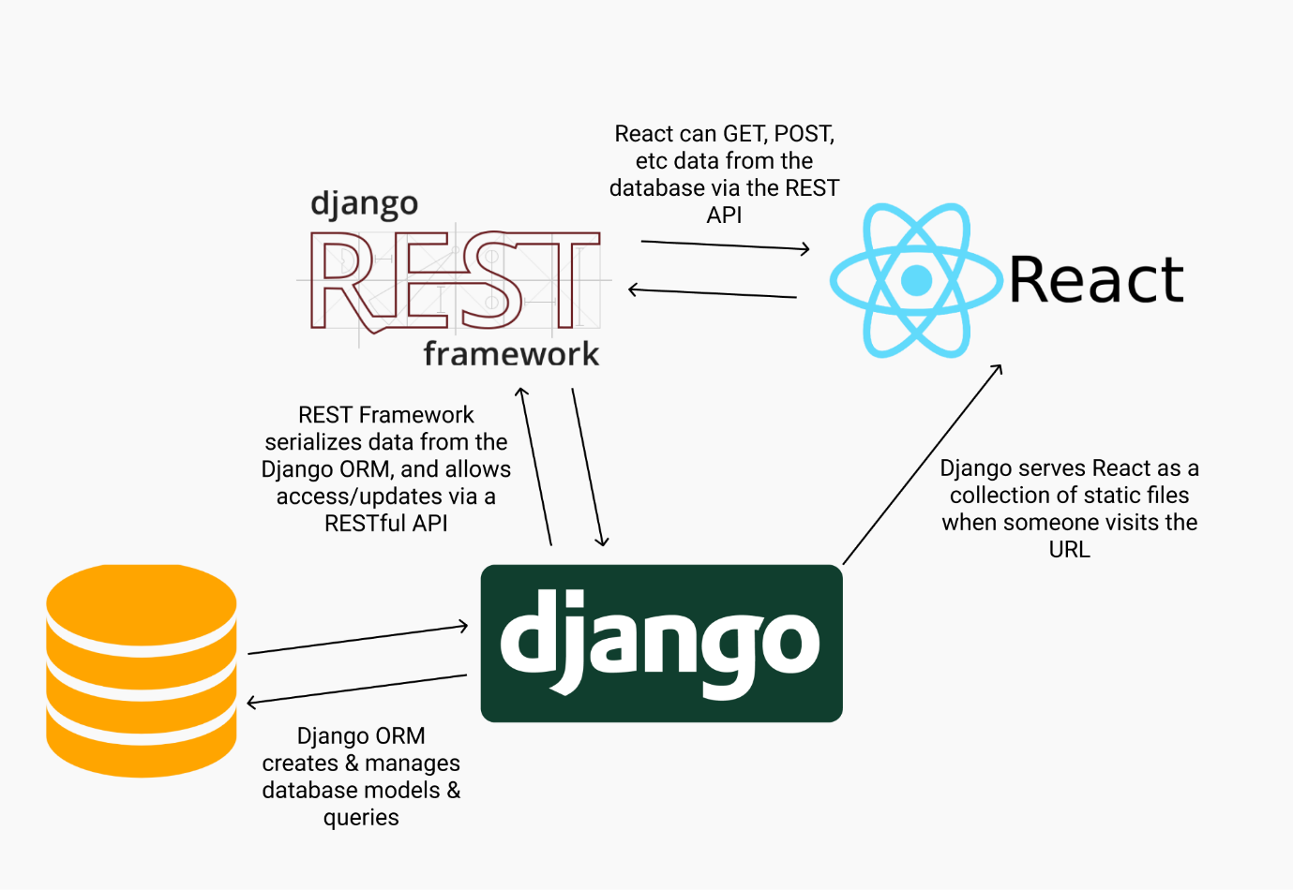

6. SYSTEM DESIGN
6.1 Introduction to UML
Unified Modeling Language (UML) is a general-purpose modeling language. The main aim of UML is to define a standard way to visualize the way a system has been designed. It is quite like blueprints used in other fields of engineering. UML is not a programming language, it is rather a visual language. We use UML diagrams to portray the behavior and structure of a system. UML helps software engineers, businessmen, and system architects with modeling, design, and analysis. The Object Management Group (OMG) adopted Unified Modelling Language as a standard in 1997. It's been managed by OMG ever since. International Organization for Standardization (ISO) published UML as an approved standard in 2005. UML has been revised over the years and is reviewed periodically.
Why do we need UML
- Complex applications need collaboration and planning from multiple teams and hence require a clear and concise way to communicate amongst them.
- Businessmen do not understand code. So, UML becomes essential to communicate with non-programmers’ essential requirements, functionalities, and processes of the system.
- A lot of time is saved down the line when teams can visualize processes, user interactions, and the static structure of the system.
UML is linked with object-oriented design and analysis. UML makes the use of elements and forms associations between them to form diagrams. Diagrams in UML can be broadly classified as:
- Structural Diagrams – Capture static aspects or structure of a system. Structural Diagrams include Component Diagrams, Object Diagrams, Class Diagrams, and Deployment Diagrams.
- Behavior Diagrams – Capture dynamic aspects or behavior of the system. Behavior diagrams include Use Case Diagrams, State Diagrams, Activity Diagrams, and Interaction Diagrams.
Building Blocks of the UML Building Blocks of the UML Building Blocks of the UML

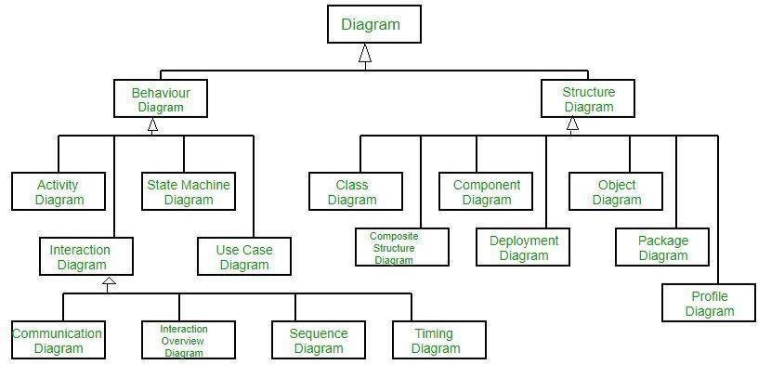

FIG 6.1 BUILDING BLOCKS IN UML

6.2 Building Blocks of the UML
The vocabulary of the UML encompasses three kinds of building blocks:
- Things
- Relationships
- Diagrams

Things are the abstractions that are first-class citizens in a model; relationships tie these things together; diagrams group interesting collections of things.
Things in the UML
There are four kinds of things in the UML:
- Structural things
- Behavioural things
- Grouping things
- Annotational things

These things are the basic object-oriented building blocks of the UML. You use them to write well-formed models.
Structural Things
Structural things are the nouns of UML models. These are the mostly static parts of a model, representing either conceptual or physical elements. Collectively, the structural things are called classifiers.
A class is a description of a set of objects that share the same attributes, operations, relationships, and semantics. A class implements one or more interfaces. Graphically, a class is rendered as a rectangle, usually including its name, attributes, and operations
Class - A Class is a set of identical things that outlines the functionality and properties of an object. It also represents the abstract class whose functionalities are not defined. Its notation is as follows

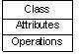

Interface - A collection of functions that specify a service of a class or component, i.e.
Externally visible behavior of that class.
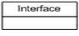

Collaboration - A larger pattern of behaviors and actions. Example: All classes and behaviors that create the modeling of a moving tank in simulation.
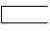

Use Case - A sequence of actions that a system performs that yields an observable result.
Used to structure behavior in a model. Is realized by collaboration.
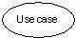

Component - A physical and replaceable part of a system that implements several interfaces. Example: a set of classes, interfaces, and collaborations.
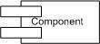
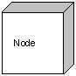
Node - A physical element existing at run time and represents are the source

Behavioral Things
Behavioral things are the dynamic parts of UML models. These are the verbs of a model, representing behavior over time and space. In all, there are three primary kinds of behavioral things
    - Interaction
    - State machine

Interaction
It is a behavior that comprises a set of messages exchanged among a set of objects or roles within a particular context to accomplish a specific purpose. The behavior of a society of objects or an individual operation may be specified with an interaction. An interaction involves several other elements, including messages, actions, and connectors (the connection between objects). Graphically, a message is rendered as a directed line, almost always including the name of its operation.

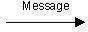

State machine
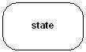
The state machine is a behavior that specifies the sequences of states an object or an interaction goes through during its lifetime in response to events, together with its responses to those events. A state machine may specify the behavior of an individual class or a collaboration of classes. A state machine involves several other elements, including states, transitions (the flow from state to state), events (things that trigger a transition), and activities (the response to a transition). Graphically, a state is rendered as a rounded rectangle, usually including its name and its substrates.

Grouping Things
Grouping things can be defined as a mechanism to group elements of a UML model together. There is only one grouping thing available.
Package − Package is the only grouping thing available for gathering structural and behavioral things.

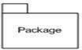

Annotation Things
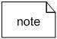
Annotation things are the explanatory parts of UML models. These are the comments you may apply to describe, illuminate, and remark about any element in a model. There is one primary kind of annotation thing, called a note. A note is simply a symbol for rendering constraints and comments attached to an element or a collection of elements.

Relationships in the UML
The relationship is another most important building block of UML. It shows how the elements are associated with each other and this association describes the functionality of an application.
There are four kinds of relationships in the UML:
- Dependency
- Association
- Generalization
- Realization

Dependency
It is an element (the independent one) that may affect the semantics of the other element (the dependent one). Graphically, a dependency is rendered as a dashed line, possibly directed, and occasionally including a label.

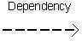

Association
Association is a set of links that connects the elements of a UML model. It also describes how many objects are taking part in that relationship.

Generalization
It is a specialization/generalization relationship in which the specialized element (the child) builds on the specification of the generalized element (the parent). The child shares the structure and the behavior of the parent. Graphically, a generalization relationship is rendered as a solid line with a hollow arrowhead pointing to the parent
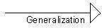

Realization
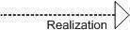
Realization can be defined as a relationship in which two elements are connected. One element describes some responsibility, which is not implemented and the other one implements them. This relationship exists in the case of interfaces.

6.3 UML DIAGRAMS
UML is a modern approach to modeling and documenting software. It is based on diagrammatic representations of software components. It is the final output, and the diagram represents the system.
UML includes the following
- Class diagram
- Object diagram
- Component diagram
- Composite structure diagram
- Use case diagram
- Sequence diagram
- Communication diagram
- State diagram
- Activity diagram

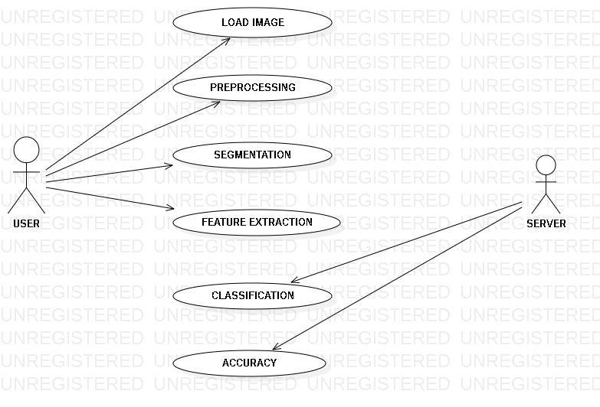
FIG 6.3.1 USE CASE DIAGRAM
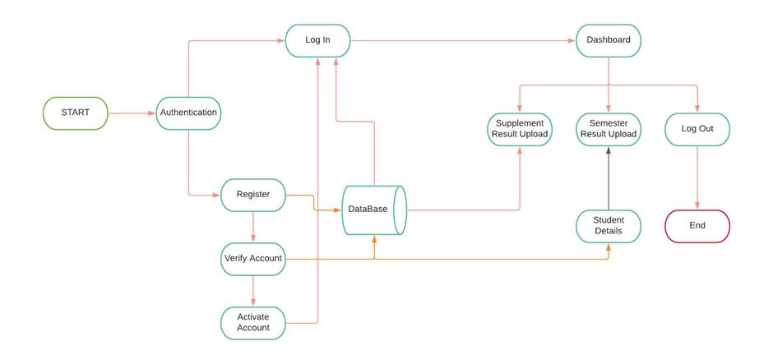
FIG 6.3.3 USE CASE DIAGRAM
REFERENCE LINKS:
https://docs.djangoproject.com/en/4.0/
https://reactjs.org/docs/getting-started.html
https://www.django-rest-framework.org/topics/documenting-your-api/

